***A Review of liver patient analysis methods using machine learning***

***INTRODUCTION***

1. ***Overview***

In Indian delayed of diseases is a fundamental problem due to a shortage of medical professionals. A Typical scenario, prevalent mostly in rural and somewhat in urban areas is:

* A patient going to a doctor with certain symptoms.
* The doctor recommending certain test like blood test, urine test etc depending on the symptoms.
* The patient taking the aforementioned tests in an analysis lab.
* The patients taking the reports back to the reports back to the hospital, where they are examined and the disease is identified.

The aim of this projects is to somewhat reduce the time delay caused due to the unnecessary back and forth shuttling between the hospital and the pathology lab.

Historically, work has been done in identifying the onset of diseases like heart disease, Parkinson’s from various features a machine algorithm will be trained to predict a liver disease in patients.

1. Purpose

* Liver cirrhosis is the biggest health problem posed by alcohol use, with 1.4 lakh deaths every year.
* Sadly, no In fact, it is getting more common is younger people than ever before.
* Cirrhosis isn’t curable, but it’s treatable. Alcohol abuse, hepatitis, and fatty liver disease are some of the main causes.
* Liver Function Tests (LFTs) are one of the most commonly-requested screening blood tests.

* Whether for the investigation of suspected liver disease, monitoring of disease activity.
* These tests can provide ahis of information on a range of disease processes.

***Problem Definition and Design Thinking***

1. **EMPATHY MAP**

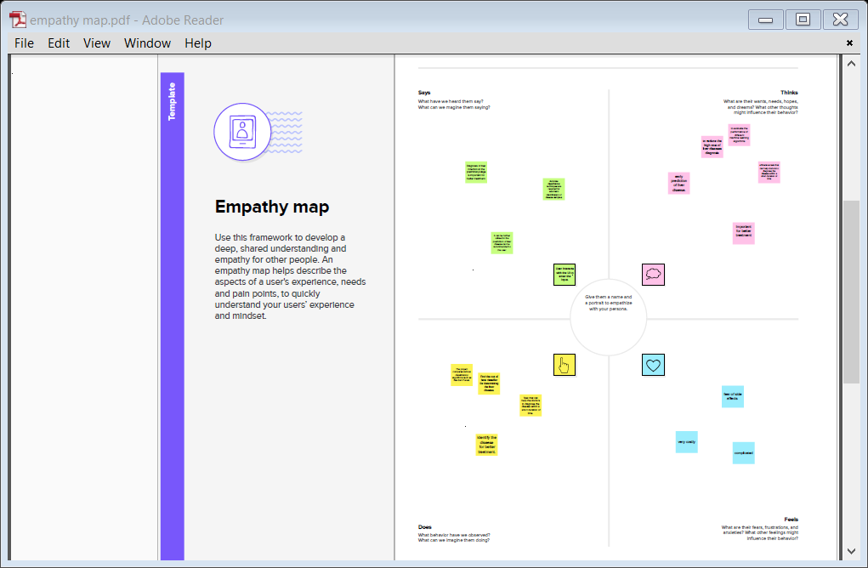

***IDEATION AND BRAINSTORMING MAP***

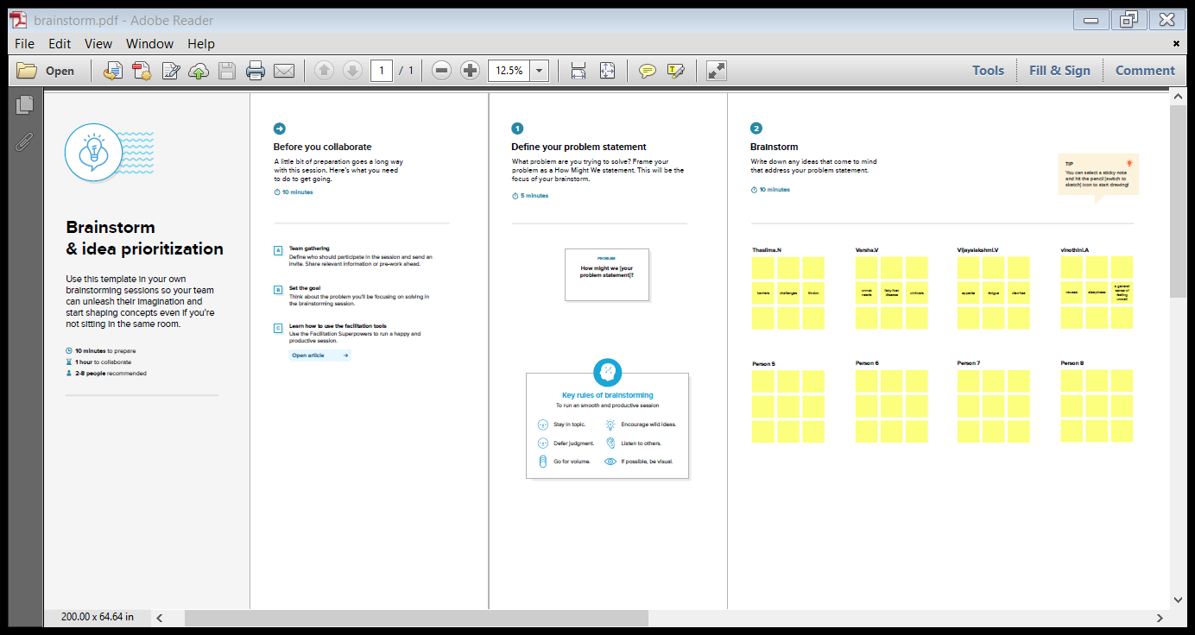

**RESULT**

**ADVANTAGES**

1. **General**

Diagnoses, grades and stages:

* Hepatitis C
* Hepatitis B
* Steatohepatitis
* Autoimmune hepatitis
* Identifies hepatotoxicity

1. **Liver Transplant**

* Identifies acute cellular rejection
* Defines recurrence of original disease
* Identifies progressive fibrosis
* Diagnoses other liver processes

**DISADVANTAGES**

**l. General**

* Invasive
* Accessibility to the procedure
* Need for training
* Repeated testing
* Cost
* Specimen length and width

**ll. Patient**

* Site pain
* Shoulder pain
* Neuralgia
* Hypotension
* Bleeding
* Pneumothorax
* Hemothorax
* Hemobilia
* Abscess
* Sepsis
* Death

***APPLICATIONS***

* + - **Html**
    - **Python**

**CONCLUSION**

Initially, the dataset was explored and made ready to be fed into the classifiers. This was achieved by removing some rows containing null values, transforming some columns which were showing and using appropriate methods (one-hot encoding) to convert the labels so that they can be useful for classification purposes. Performance metrics on which the models would be evaluated were decided .The dataset was then split into a training and testing set.

Firstly, a naive predictor and a benchmark model (‘Logistic Regression’) were run on the dataset to determine the benchmark value of accuracy. The greatest difficulty in the execution of this project was faced in two areas- determining the algorithms for training and choosing proper parameters for fine-tuning.

Initially, I found it very vexing to decide upon 3 or 4 techniques out of the numerous options available in sklearn. This exercise made me realize that parameter tuning is not only a very interesting but also a very important part of machine learning. I think this area can warrant further improvement, if we are willing to invest a greater amount of time as well as computing power.

***FUTURE SCOPE***

* Further we will use this model for flask integration.
* The future methodology is used to analyse the liver region into separable compartments i.e. liver etc.

* PSO has been widely used for feature selection to improve liver classification performance.
* The methods requires further improvement mostly regarding feature selection of the liver into multiple components: renal cortex, renal column, renal medulla and renal pelvis.
* There is a scope to further reduce search space for better liver classification accuracy if enhanced selection and mutation procedures are being used.

**APPENDIX**

**l. Source Code**



